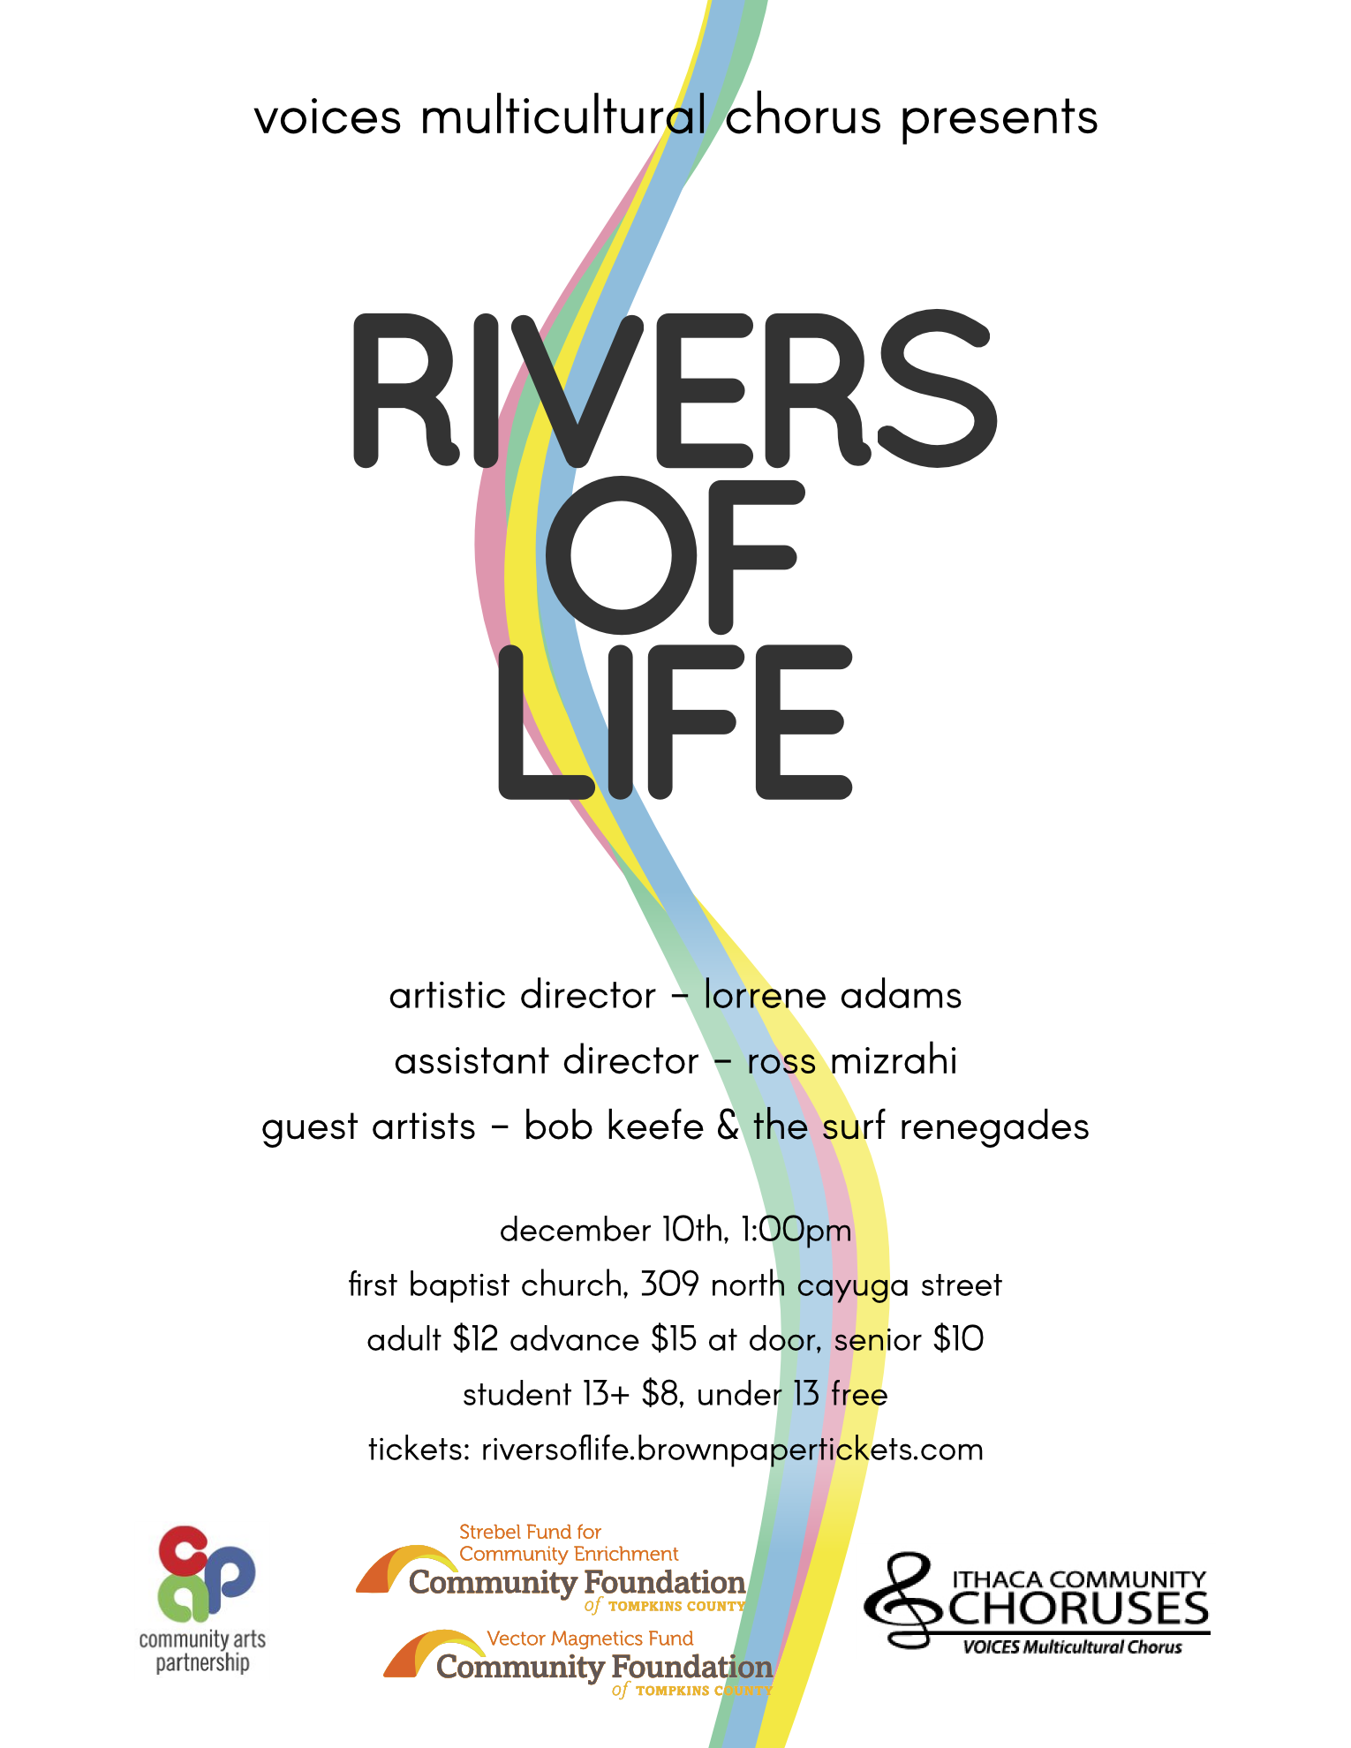

**Rivers of Life**

with Artistic Director Lorrene Adams and Assistant Director Ross Mizrahi

December 10, 2016, 1 pm

**PROGRAM**

**VOICES**

**Ukrainian River Song** words & music by Roman Yakub

Kyler Davis, cello

Ross Mizrahi, tambourine

**Riversong (A Celtic Celebration)** words & music by Roger Emerson

Lisa Baclawski, flute

Makaela Garcia, violin

Bob Keefe, guitar

Ellen Miller, bass

Ross Mizrahi, bodhran

**Te Quiero** music by Alberto Favero

words by Mario Benedetti

arr. Liliana Cangiano

Joo Hyun Im & Dan Bergdorf, solos

**Shenandoah** American Folksong

arr. James Erb

Lisa Baclawski, solo

**Molihua** Chinese Traditional Song

arr. Reed Criddle

**Waters Ripple and Flow** Czecho-Slovak Folksong

arr. Deems Taylor

Lisa Camilli & Josh Hochman, solos

**INTERMISSION**

**The Surf Renegades**

**To Be Announced**

**VOICES & the Surf Renegades**

**Watching the River Flow** Bob Dylan

arr. Bob Keefe

Rich Recchia, solo

**Up on Cripple Creek** words & music by Robbie Robertson

arr. Bob Keefe

Ross Mizrahi, solo

**River of Dreams** words & music by Billy Joel

arr. Mark Brymer

Lisa Baclawski & Sherrie Norman, solos

Mark Joyce, set

Ellen Miller, bass

**Proud Mary** words & music by John Fogerty

arr. Kirby Shaw

**-------------- PROGRAM NOTES --------------**

**Ukrainian River Song**

The Carpathian Mountains of Ukraine sit in the heart of Europe and are home to many different ethnic groups of Eastern Slavic origins.  Various cultures have influenced the musical heritage of this region: Hungarian, Romanian, Gypsy, Eastern European Jewish, Ukranian, Slovak, and others.  This music, in its turn, influenced the neighboring cultures.  One of the most popular folk songs/dances is Kolomyika, its name derived from the town of Kolomyia.  Although *Ukrainian River Song* is not structurally and rhythmically a Kolomyika, it resembles the spirit of this popular dance.  The instrumental part in the middle of the song is almost a precise quotation of the very famous original Kolomyika.

**Riversong**

Anyone who has experienced the wonderful sounds of Celtic music will respond enthusiastically to this exceptional Roger Emerson original, which captures all the spark and color of the Celtic tradition.  “Dance to the tune, sing to the moon, aye, shule a-roon; let the river take you!”  "Shule a-roon" is Irish, similar to, "Come with me, my love."  Think of it as a sort of, "Let us steal away.  Come with me my love, away, to waters by the sea..."

**Te Quiero**

*Te Quiero* is an original song from the Argentinian popular music composer Alberto Favero.  He sets to music a moving poem of Mario Benedetti.  Benedetti, whose works include a vast collection of poems, novels, and tales, always writes in a very clear and expressive manner.  His solidarity with the Latin-American people and the sincerity with which he expresses the social, political, and economic problems of the continent have won him world-wide recognition.  The music of Alberto Favero is vivid and expressive, and the choral arrangement of Liliana Cangiano gives a new dimension to this work.

Lyrics translation:

*If I adore you it is because you are my love, my intimate friend, my all;*

*and in the street, arm in arm, we are so much more than two.*

*Your hands are my caress, my daily affirmations.*

*I love you because your hands work for justice.*

*Your eyes are my lucky charm against misfortune.*

*I adore you for your gaze that looks to and creates the future.*

*Your mouth is yours and mine; your mouth is never mistaken:*

*I love you because your mouth knows how to cry out for rebellion.*

*And for your sincere face and wandering spirit*

*and your weeping for the world—because you are the people, I love you.*

*And because our love is neither famous nor naïve,*

*and because we are a couple that knows we are not alone.*

*I want you in my paradise, which is to say, in my country;*

*I want the people to live happily even though they aren’t allowed to!*

**Shenandoah**

*Shenandoah* or "Across the Wide Missouri" is a traditional American folk song of uncertain origin, dating to the early 19th century.  The song appears to have originated with Canadian and American voyagers or fur traders traveling down the Missouri River in canoes, and it has developed several different sets of lyrics. Some lyrics refer to the Native American chief "Shenandoah" (Oskanondonha) and a canoe-going trader who wants to marry his daughter.  By the mid 1800s, versions of the song had become a sea shanty heard or sung by sailors in various parts of the world.

**Molihua**

*Mo Li Hua*, literally: "Jasmine Flower", is a popular Chinese folk song.  The song dates back to the 18th century. In time, many regional variations were created, and the song gained popularity both in China and abroad.  It has been used during events such as 2004 and 2008 Summer Olympics, the 2010 Shanghai Expo opening ceremony, and, controversially, the 2011 Chinese protests.

Lyrics translation:

*Beautiful jasmine flower, beautiful jasmine flower,*

*Beautiful perfumed blossoms fill the branch, fragrant and white for everyone’s delight.*

*Let me come and pick a blossom to give to others, to loved ones—to him, to her.*

*Beautiful jasmine flower, beautiful jasmine flower.*

**Waters Ripple and Flow**

"Listen to the river, listen to the sea, joining with the earth in a song of peace..."  You will hear water rushing on its way to the sea; you will see the sun dancing on the water. The melody of this Czecho-Slovak folksong is gorgeous and expressive, moving majestically over the flowing accompaniment, while the words carry an important message of peace.

Lyrics translation:

*Waters ripple and flow, slowly passes each day;*

*Faithless lover of mine, stay no longer away;*

*Faithless lover of mine, stay no longer away.*

*Dear one, well dost thou know why fond lovers must part:*

*Wherefore falters thy faith? Why so timid thy heart?*

*Wherefore falters thy faith? Why so timid thy heart?*

*Dearest lover, come back; end the vigil I keep.*

*Thine, the key to my heart, mine, without thee to weep.*

*Thine, the key to my heart, mine, without thee to weep!*

*When the mountain shall turn, when the victory is thine,*

*Then my happiness dawns, then shall freedom be mine;*

*Then my happiness dawns, then shall freedom be mine.*

*Lo, the mountain has turned, now the victory is thine;*

*Now my happiness dawns, now shall freedom be mine,*

*Now my happiness dawns, now shall freedom be mine,*

*Now shall freedom be mine!*

**Watching the River Flow**

*Watching the River Flow* is a song by Bob Dylan. It was written and recorded during sessions in spring 1971 at Blue Rock Studios in New York City and produced by Leon Russell. The recording was issued as a single on June 3, 1971. It reached the Top 40 in multiple countries and No. 41 in the United States. It has appeared on various Dylan compilation albums and has been covered by numerous other artists. Since 1987, Dylan has performed the composition often at his concerts. Critics have written that, in this song, Dylan sang about the temptation to withdraw from public life and the problem of lack of inspiration.

**Up on Cripple Creek**

A hit song from The Band, *Up on Cripple Creek* draws upon The Band's musical roots, the American South, American rock and roll, and bluegrass/country. The song is sung from the point of view of, perhaps, a driver who goes to Lake Charles, Louisiana, to stay with a local girl, Bessie, with whom he has a history. In the song, he gambles, drinks, listens to music, and spends time with "little Bessie," who takes an active role in the goings-on while expressing her opinions, further endearing herself to the narrator. At the end of the song, after exhausting himself on the road, he talks about going home to his woman, "big mama," but is tempted to return to Bessie again. Or he may not have cheating on his mind: Truckers also use the term "Big Mama" to refer to their dispatcher over the CB radio. Concerns about the weather in other parts of the country and the line "this life of living on the road" suggest over-the-road trucking. At the start of the song, he's hauling logs off a mountain, and at the end he may be weighing options: "rolling in" to home base for a new cargo or seeing his Bessie again.

**River of Dreams**

*River of Dreams* is the twelfth studio album and last rock album by American singer-songwriter Billy Joel, released on August 10, 1993. Joel stopped recording new music as a performer after this album, although he has subsequently released live albums and composed the music for an instrumental album performed by Richard Joo. River of Dreams presented a much more serious tone from Joel than did his previous albums, dealing with issues such as trust and long-lasting love. It was rumored that the themes of trust and betrayal, particularly certain lyrics from the songs "A Minor Variation" and "The Great Wall of China", stem from Joel's legal disputes with his former manager and ex-brother-in-law, Frank Weber, who reportedly embezzled millions of dollars from Joel and used dubious accounting practices to cover it up.

**Proud Mary**

*Proud Mary* is a rock song written by John Fogerty and first recorded by his band Creedence Clearwater Revival. The song became a major hit in the United States, peaking at #2 on the Billboard Hot 100 in March 1969, the first of five non-consecutive singles to peak at #2 for the group.  Ike & Tina Turner first covered “Proud Mary” in 1970. Their version was released as a single from their *Workin' Together* album. The song differed greatly from the structure of the original, but it is also well known and has become one of Tina Turner's most recognizable signature songs.

**-------------- The Surf Renegades --------------**

Bob Keefe lead guitar

Josh Slusar rhythm guitar

Jack McKissick bass

Mark Joyce drums

**------- VOICES Multicultural Chorus Singers & Members -------**

**Soprano**

Lisa Baclawski

Patricia Baxter

Carol Booth  
Lisa Camilli

Susan Crowell  
Amy Davis  
Brittany Jaromin  
Melody Johnson  
Susie Kossack

Ellie Rosenberg  
Margaret Shepard  
Christine Sparfel

**Alto**

Sherry Altman

Kelly Doolittle

Linda Duttweiler  
Tilly Garnett  
Cynthia Howell

Joo Huyn Im

Andrea Kabcenell  
Noemi Kraut

Julie Lauren

Sabine Mann  
Sherrie Norman

Therese O’Connor  
Carol Ornstein

Barbara Schwartz  
Alison Taren

Lena Trancik  
Catherine Wagner

Erica Weiss  
Carol Whitlow

Cora Yao

**Tenor**

Fran Barraclough

Dan Burgdorf

Kyler Davis  
Mike Duttweiler  
Vicki Gayle

Elaine Gries

Barbara Kane-Lewis  
Ron Liso   
Lee Moon  
Veronica Pillar  
Helen Saunders

**Bass**  
David Gries

Josh Hochman

Peter Kahn  
Bill Lesser

Ross Mizrahi  
Luigi Morelli  
Ed Olmstead  
Dave Rappleye  
Richard Recchia

Daniel Ripperton  
James Skaley

**-------------- Our Accompanist ---------------**

**Rachel Hidlay** began piano lessons at six years old and has since come to love making and sharing music with others. At sixteen she was hired by Bloomsburg University as a piano instructor in the Piano Preparatory Department. Shortly after this she opened a private studio in her home.  She holds a Bachelor’s degree in piano performance with extra credits in music education from Liberty University, as well as a Master’s degree in piano performance from Ithaca College where she studied with Dr. Jennifer Hayghe. She is currently completing an advanced certification in piano pedagogy.

Rachel teaches students of all ages and skill levels. She held teaching positions at Nazareth College, Ithaca College, Community Music School in Ithaca, NY and the St. Peters Community Arts Academy in Geneva, NY. She currently maintains a private studio of 40 students in her home. Rachel also is on staff as an accompanist for Lansing School District. Rachel loves all facets of music. She strongly believes music making/learning is a wonderfully unique journey, one that can enlighten and enrich a person's life. She greatly enjoys helping others navigate their personal musical experiences.

**-------------- Our Donors --------------**

|  |
| --- |
| **Donations received November 1, 2015 - October 31, 2016** |

|  |
| --- |
|  |

|  |
| --- |
| **Angels ($1,000 and over)**  Cayuga Radio Group |
| Community Arts  Partnership |
| Linda & Stephen Pope  Loyd Powell |
| Elizabeth Schermerhorn |
| The Vector Magnetics  Fund of the Community  Foundation |
|  |
| **Benefactors ($500-$999)** |
| Anonymous |
| Marilyn Crooker |
| Diana Nathanielsz |
| William Schoch |
| The Strebel Fund for  Community Enrichment  of the Community  Foundation |
| Robert & Pamela  Swieringa |
| Annie Wall |
|  |
| **Patrons ($100-$499)** |
| Wolfgang & Anne  Baerwald |
| Erik & Suner Beukenkamp  Michael & Joyce Billing  Marcia & John Bishop |
| Jack Booker  Percy Browning |
| Elissa Cogan & Barry  Chester |
| Linda & Michael  Duttweiler |
| Eaton Charitable Trust |
| Elizabeth Einstein |
| William Goldsmith |
| Katherine Gottschalk |
| Ellen Harrison  Eva & Roald Hoffman |
| Margaret Keller |
| Noemi Kraut |
| William Lesser |
| Susan McMurry |
| Miriam Melegrito  Robert S. Miller |
| Elizabeth (Lee) Moon |
| Susanne Morgan |
| Yvonne Parkes |
| Jeanne Pellerin |
| Wendy Robertson |
| Mary Royer |
| Helen Saunders |
| Rocco & Sherry  Scanza |
| Paul & Mary Slade |
| Janine Willis |
|  |
| **Sponsors ($50-$99)** |
| Ken & Susan Brown  Carla Gallery of Fine  Jewelry |
| David & Linda Caughey |
| Candace Collmer |
| Paul Feeny & Mary Berens |
| Clare Fewtrell |
| David Flinn  Myles Gideon |
| Kurt & Sorel Gottfried |
| James Hedlund |
| Louise & Neil Hertz |
| Tiina Kurman |
| Eddy & Lorraine LaDue |
| Julie Lauren |
| Polina Levina |
| Kathleen Lilley |
| Lynn Leopold |
| Linda Loomis  Tamara Lovell  Jackie Magagnosc |
| Glenna Margaris |
| Saoirse McClory &  Lawrence Hirschberger |
| Philip & Alice Meilman |
| Ruth Meyburg  Stephanie Meyer  Margaret Nichols |
| Richard & Linda Shaff |
| Marjorie Smart |
| Robbert Van Renesse &  Lesley Green |
| John Wootton |
| Nancy Young &  William George |
|  |
| **Supporters ($25-$49)** |
| Marilyn Baurle |
| David Feldshuh & Martha  Frommelt |
| Martin Ginsburg |
| Melvin Goldman |
| Melody Johnson |
| Sarah Johnson |
| Kathy Kelly  Meridith Kusch |
| Edward Olmstead |
| Sheila Reakes  Melzar Richards  Andre Spies  Margaret VanHoutte  Shannon McCune Wagner  Hilary Dorsch Wong |
|  |
| **Friends** |
| Fred Coppola |
| Franziska Dellinger |
| Irene Eibenstein-Alvisi  Tilly Garnett  David Gooding  Elaine Gries |
| Cynthia Howell |
| Shane Knezevic |
| Ruth Mahr  Jean McPheeters |
| Jack Miller |
| Teresa Porri  Catherine Porter  Rosalie Richter |
| Mihal Ronen |
| Charlotte Rosen |
| Connie Thomas |
| Sharon Ziegler |
|  |
| **Paul Gibbons Scholarship**  **gifts** |
| Ithaca Community Chorus &  Chamber Singers Members |
| Members |

**-------------- Acknowledgements of Gratitude --------------**

**VOICES also thanks:**  
Tompkins County Courthouse board meeting space  
Unitarian Church of Ithaca weekly rehearsal space  
Elizabeth Einstein, Ellie Rosenberg calendar fundraiser  
Cora Yao music librarian  
Ed Olmstead e-newsletter editor, rehearsal setup  
Mike Duttweiler registration  
Katherine Kiblinger Gottschalk ICC concert program ad sales coordinator  
Bennett Purdy concert program cover and advertising poster artist  
Veronica Pillar program layout  
Mike Duttweiler, Sherrie Norman, Kelly Doolittle publicity  
Sherrie Norman tickets  
David Gries stage manager

Julie Lauren house manager  
Franziska Dellinger, Ed Olmstead web master

**Our Steering Committee:**  
Sherrie Norman President  
Mike Duttweiler Treasurer  
William Henri Lesser Recorder  
Kelly Doolittle, Elaine Gries, Cynthia Howell Members-At-Large  
  
**ICC Board Officers:**  
Carol Whitlow Chairperson  
Annie Wall Financial Manager  
Myles Gideon Treasurer  
Andrea Kabcenell Secretary

**Please support our advertisers with your business!**

**See our program shell for more information.**

**---------------------------------------------------------------------------**

Do YOU like to sing? If so, join our no-auditions, no-experience-needed community choruses! You don’t even have to read music.

See <http://www.ithacacommunitychoruses.org> for more information.

Online registration will be available in mid-December at: <http://www.ithacacommunitychoruses.org/groups/voices/join>



**VOICES Multicultural Chorus is a project of the Ithaca Community Choruses, a 501c3 nonprofit organization.**